**KNN CLASSIFIER**

**Business Problem** = ﻿ ﻿Implement a KNN model to classify the animals in to categories.

* **Name of the File: -** Zoo.csv
* **Size of the File: -** 8 KB
* **Necessary Data : -** 102 Observations, 18 Features.

**Exploratory data Analysis** =

* **Outliers: -**  Outliers are not presents.
* **Missing Value: -** Data don’t have Missing Values
* **Output:** - Numeric

**Building Initial KNN Model =** Building the first KNN model by taking the square root of total observation in train data as a K value.

* **﻿N Neighbors (K) :-** 9
* **﻿Accuracy Score :-** 88 %
* 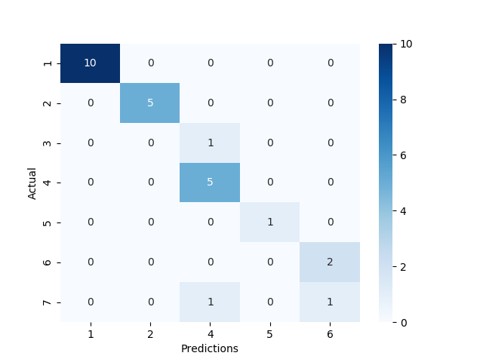**Confusion Matrix : -**

Let’s try to increase model accuracy my selecting optimized value of K.

**Selecting Perfect K Value =** We can select optimized K value by performing the KNN model on different K values iteratively. I am using Elbow Curve to plot Accuracy of model on different K values.

* 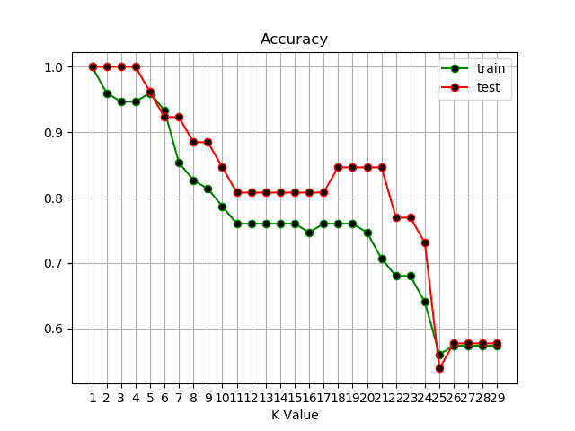**﻿Accuracy Elbow Plot : -**

From the above Elbow plot, we can conclude that the optimized odd K value for better accuracy and less Error is 5 which is given by both train and test data. Odd K value takes a decision based on the majority instead of distance Hence, it gives more accurate results. So we are training our final model by selecting K as 5.

**Building Final KNN Model =**

* **N Neighbors (K) :-** 5
* **﻿Accuracy Score :-** 96 % (on both Train and Test)
* 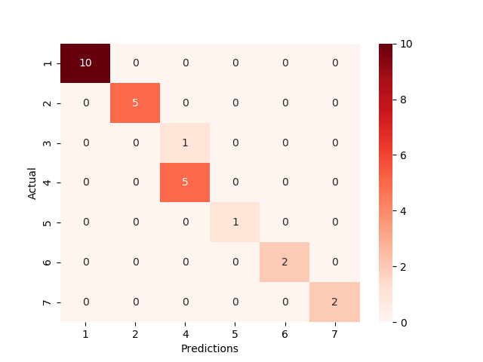**Confusion Matrix : -**

After Selecting K as 3, our model accuracy apparently increased. Now model accuracy is greater than 72% and we can say that its quite good accuracy. So we use this model as our final model.

**Python code file**: - [Zoo Analysis.py](https://github.com/nilaydeshmukh0/K-Nearest-Neighbor-Classifier-KNN/blob/master/Zoo%20Analysis/Zoo%20Analysis.py)